

ICT PROJECT TASK 1

PROJECT DOCUMENTATION

**Ramandeep Singh Dhillon-jc455953**

**Sukhdeep Kaur**

**Harpreet Kaur**

**Bhoomibahen Raval-jc458537**

1. **Team Description-**

Our team is working to develop a website to fulfil our client requirement. The client requirement is to develop a website to rescue a Bullterrier Rescue in Queensland. We are four members in a team, working together and contributing together to fulfil our client requirement towards achieve our goal. We have divided our tasks individually to complete our task. Different contribution towards our goals are-

1. Individual contribution-

**1. Ramandeep Singh Dhillon(jc455953)**

-Prepared Client Agreement

-Described Project Description and Goals and Deliverables

-Created user log

**2. Sukhdeep Kaur**

-Interacting with the Client and writing User Stories

-Timeline project requirement

**3. Harpreet Kaur**

-User stories

-Implementation of milestone

**4. Bhoomibahen Raval (jc458537)**

-User stories

-Created user log

-Prototypes

**b) Project Description**

Our project is based on to develop a website to rescue Bullterrier in only Queensland. The main aim of business is to the rescue most admired for its people, partnerships and performance of helping Bull Terriers and placing them in appropriate forever homes. Various organisations are available in market but there is no any other organisation is available that rescues only Bullterrier dog especially in Queensland who supports best training for dogs by volunteers are dedicated to the welfare of Bull Terriers and operate a comprehensive rescue and re-homing service.<https://www.petrescue.com.au/groups/10769/Qld-Bull-Terrier-Rescue>is available but its like a charity.

**c) Project Goals-**

Project goals describe how and what proposed ICT solution will be delivered to the client. Various goals are described as:

* First goals of our project to rescue Bullterrier dogs from various parts of Queensland who are in need.
* The second goal of our project is provide training them and get ready for rehoming.
* The third goal of project to find people who wants to adopt dogs by providing details of those dogs and find the circumstances in which those dogs can fit by getting information about people through adoption form.

**d) Justification between major milestones with timeline-**

To justify major milestones with timeline the team work has divided according to the needs of client requirement so that every activity can be finish on time by designing and planning. The tasks are going to be done according to thepriorities. Our proposed is neither too ambitious nor too conservative, it’s all depends upon the team effort.

**2. Project Audit-**

**a) Milestone 1: Alpha Release**

The starting date of Alpha Release: 14th November, 2017 and ending date 27st February, 2018.There are five pages included in alpha Release, which the client provides more priority. For example, Dogs available, landing page (Home page), Adoption, Admin (Add/edit dogs), Admin Dashboard.

|  |  |  |  |  |  |
| --- | --- | --- | --- | --- | --- |
| Release | No | User Story | Description | Priority | Time(days) |
| Alpha ICT 1  5 Weeks | **1** | Landing Page(Home) | It describes all menu options and website description(Mission) | 10 | 2 |
| **2** | Dogs Available | This page provide description of dogs .So that viewer can find dogs for adoption | 10 | 3 |
| **3** | Admin | In this page admin can add and edit dogs available for adoption. | 10 | 3 |
| **4** | Adoption | In this page visitor can fill out form with personal details for adopt a dog . | 10 | 4 |
| **5** | Admin Dashboard | Admin can access admin dashboard with admin options such as change password, receive and manage forms, add/edit photo gallery, add/edit testimonials. | 10 | 4 |

**Title:** Landing Page(Home page)

**Description:**

**As a …** Visitor

**I need …** Home(landing Page)

**So that …** I can find all menu options+website description(Mission)

**Priority: 10 Time estimate: 2**

**Priority: Time estimate:**

**Title:** Dogs Available

**Description:**

**As a …** visitor

**I need …** page,pictures,details of dogs

**So that …** I can read description of dogs and I can find dogs for adoption

**Priority: 10 Time estimate:3**

**Title:** Admin Add/Edit Dogs

**Description:**

**As a …**site admin

**I need …** forms in dashboard

**So that** … I can add and edit dogs available for adoption

**Priority:10 Time estimate: 3**

**Title: Adoption**

**Description:**

**As a … Visitor**

**I need …** form to fill out with details

**So that …** I can contact admin and express interest to adopt a dog

**Priority: 10 Time estimate: 4**

**Title:** Admin Dashboard

**Description:**

**As a …** site admin

**I need …** login form

**So that …** I can access admin dashboard with admin options

**Priority: 10 Time estimate: 4**

1. **Milestone 2: Beta Release**

The starting date of Beta Release: 12th March 2018 and ending date will be 15th June, 2018. In the beta Release six pages will be included For instance Contact Us, About Us, about our breed, our programs/events, Rehoming, Foster form. In beta release there might be some changes will also done according to the client Requirement. And in the end of beta release Debugging and testing will also be done.

|  |  |  |  |  |  |
| --- | --- | --- | --- | --- | --- |
| Release | No | User Story | Description | Priority | Time(days) |
| Alpha ICT 2  5 Weeks | **1** | Contact Us | It describes contact details and location. | 30 | 3 |
| **2** | About Us | This page describes mission of website. | 30 | 3 |
| **3** | Foster Form/fostering  question | In this page visitor can fill out form after reading fostering questions | 30 | 5 |
| **4** | Rehoming | In this page visitor can read information of adoption fees. | 30 | 2 |
| **5** | Our Programmes/  events | Details about upcoming events and different programs. | 30 | 4 |
|  | **6** | About-our-breed | This page will provide Information about rescue dogs. | 30 | 3 |
|  |  |  |  |  |  |

**Title:** About Us

**Description:**

**As a …** Visitor

**I need …** Information of website

**So that** … I can understand mission of the website

**Priority: 30 Time estimate: 3**

**Title:** Contact Us

**Description:**

**As a …** Visitor

**I need …** contact details and location

**So that …** I can contact them

**Priority: 30 Time estimate: 3**

**Title:** Rehoming

**Description:**

**As a …** visitor

**I need …** to know about adoption fees and requirements

**So that …** I can decide to adopt dog

**Priority: 30 Time estimate: 2**

**Title:** Foster form/ fostering questions

**Description:**

**As a …**Visitor

**I need …** foster application form to fill out

**So that …** I can fill out form with my personal information and understand fostering questions

**Priority: 30 Time estimate: 5**

**Title: our programmes/events**

**Description:**

**As a …Visitors**

**I need …details about upcoming event and programmes**

**So that … I can know about different programmes and events**

**Priority: 30 Time estimate:4**

**Title: About-our-breed**

**Description:**

**As a … Visitor**

**I need … to read about dogs and mission of website**

**So that … I can understand everything related to dogs**

**Priority: 30 Time estimate: 3**

**Clients Signed Agreement:**

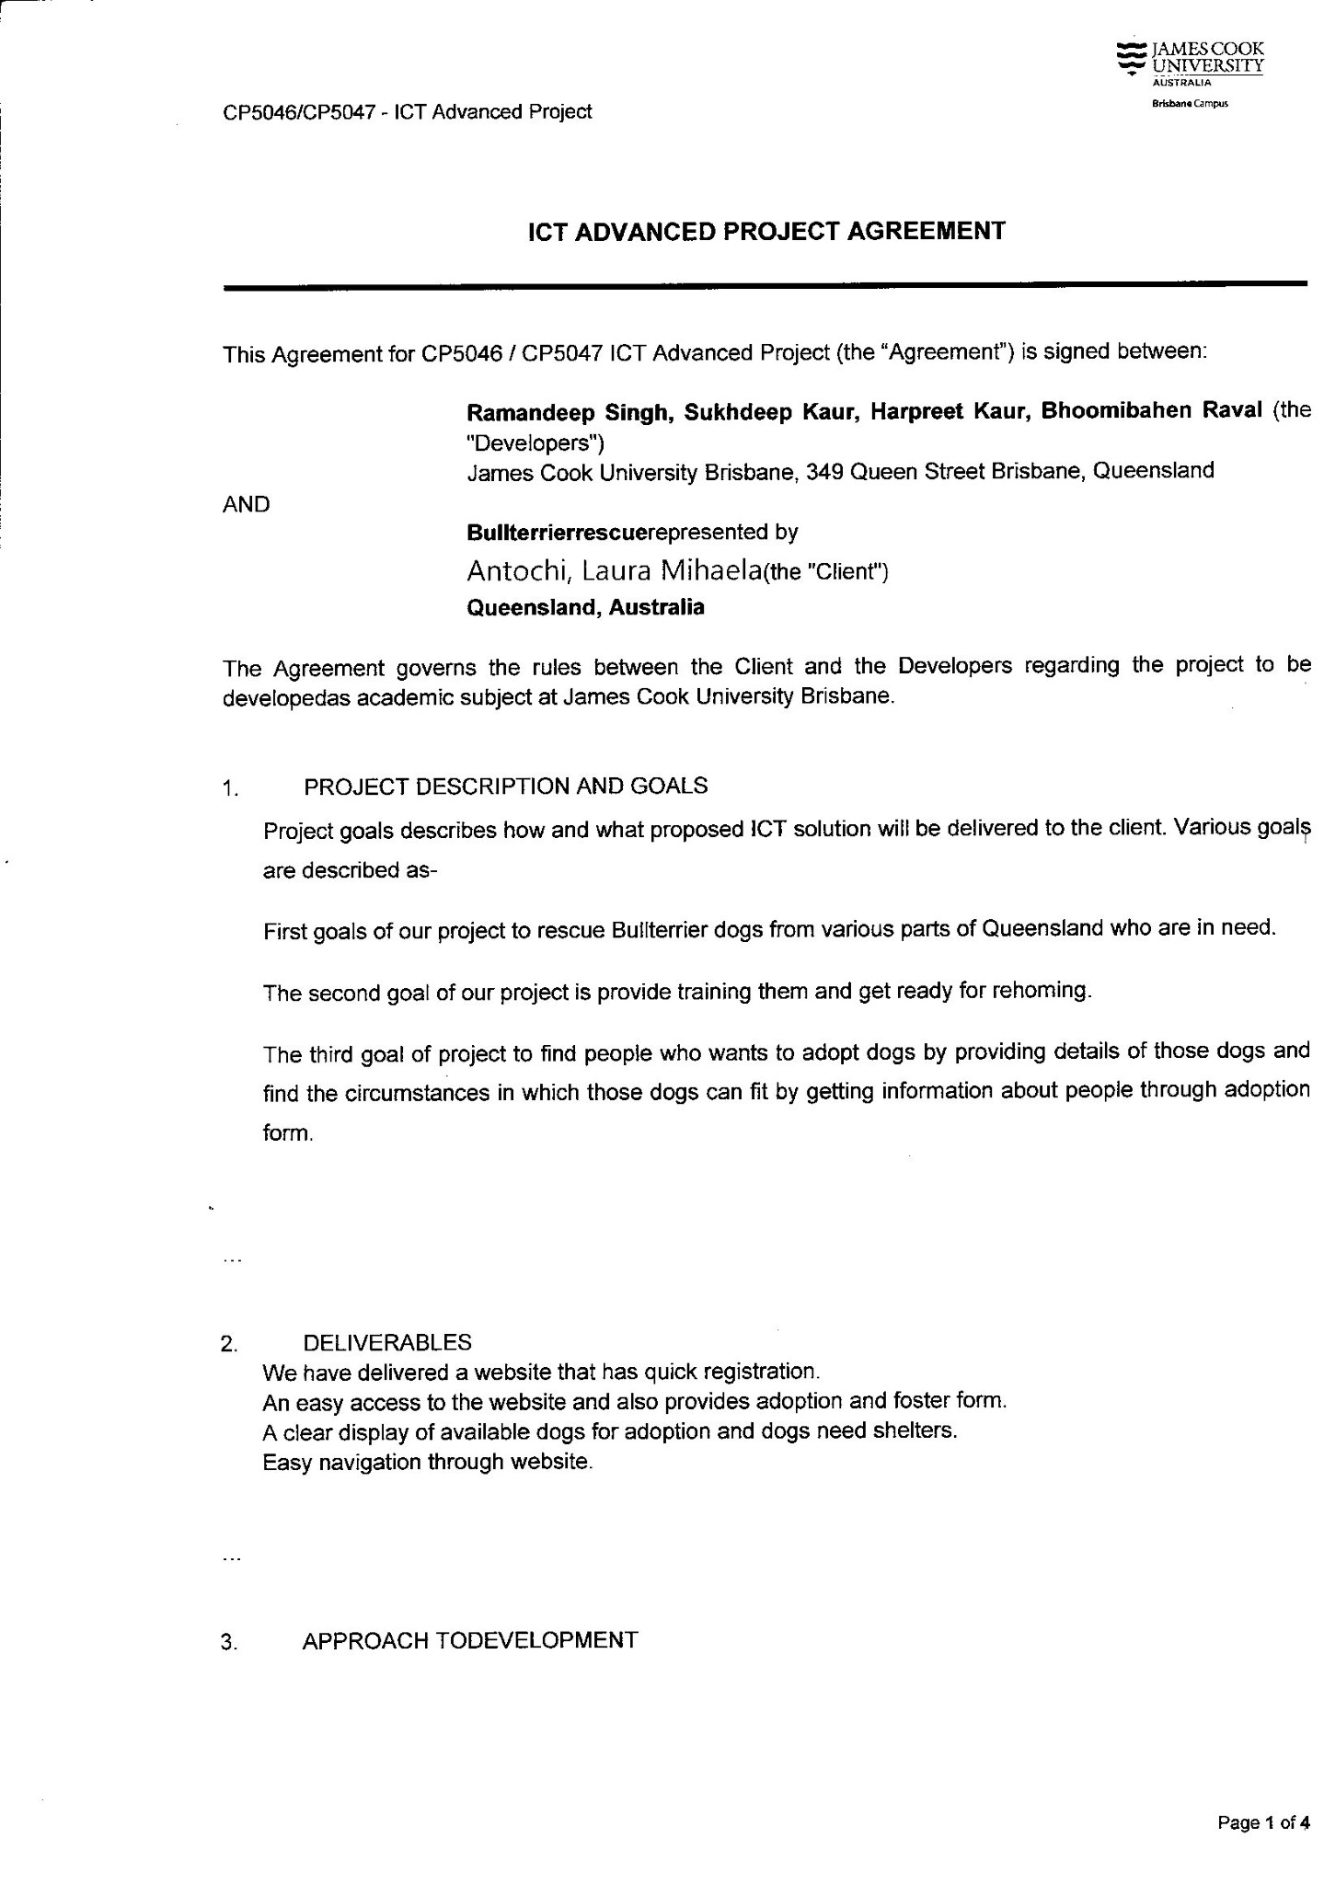

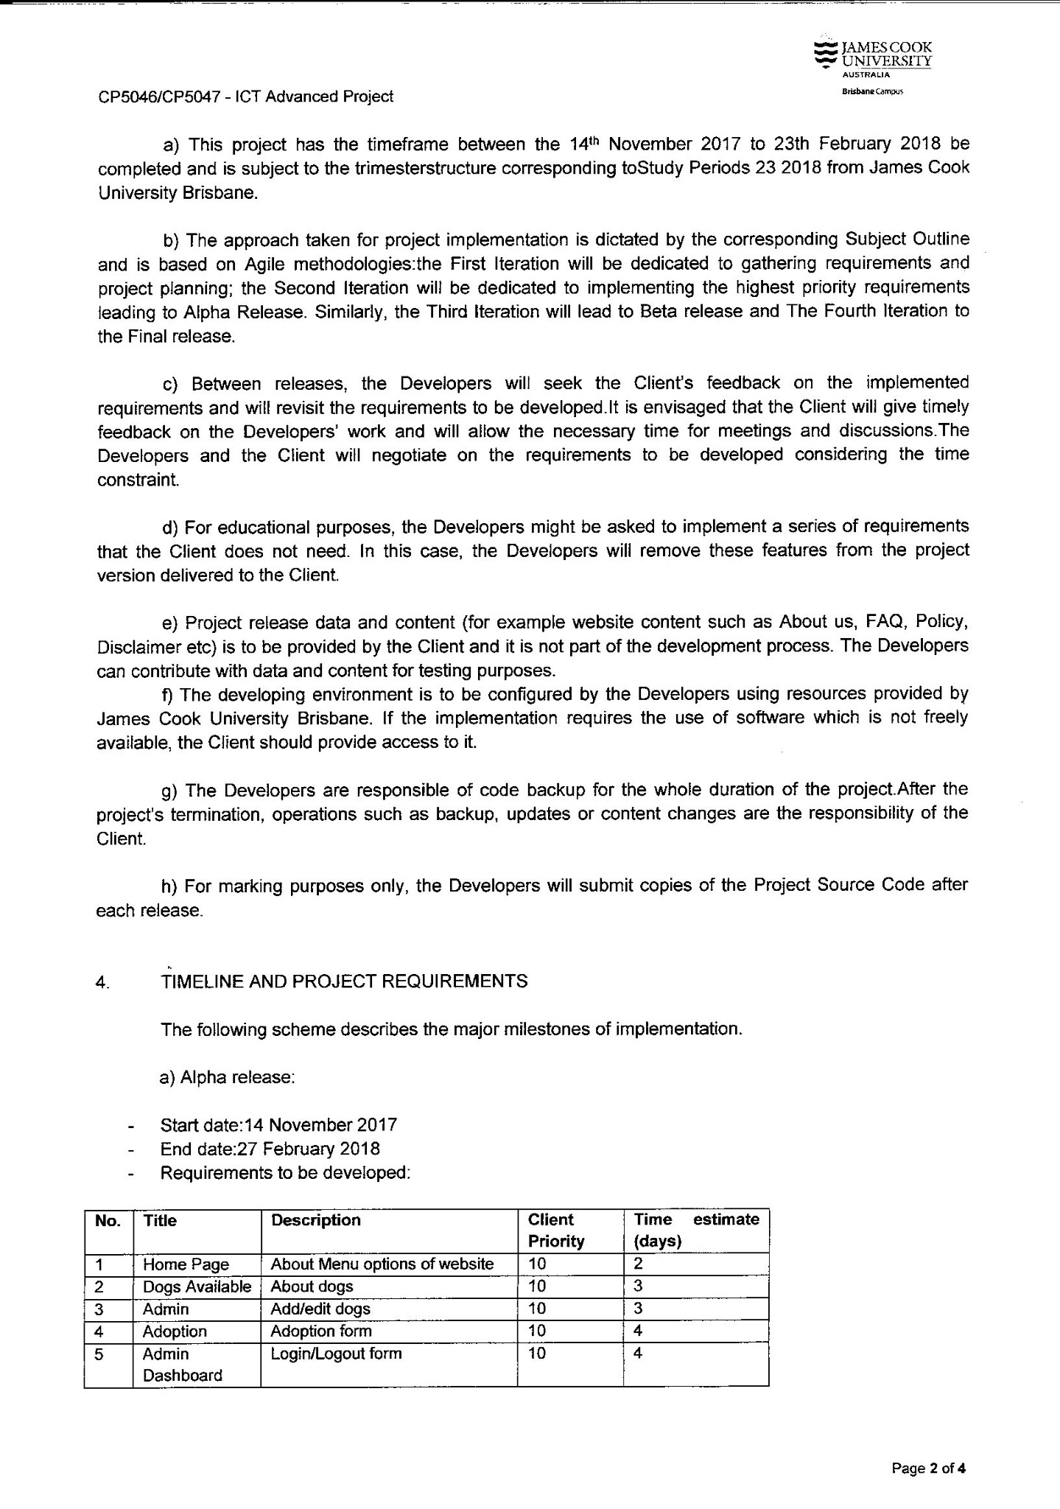

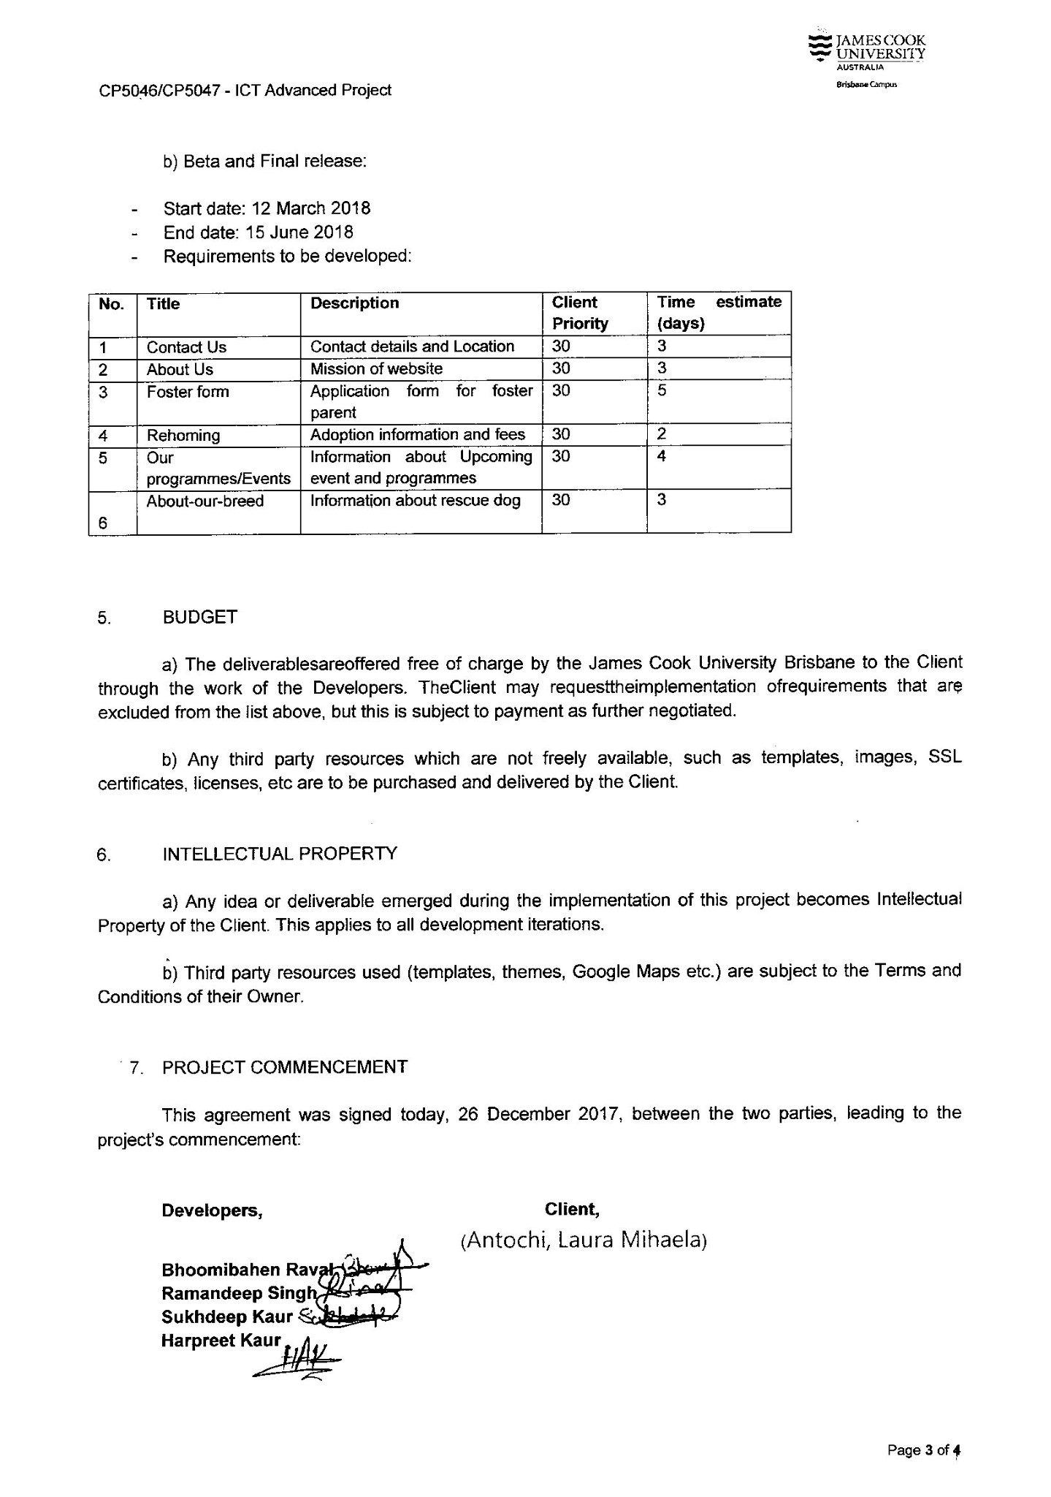

Laura Antochi



**Project development and release**

1. **Configuration management**

**Github**

Github is a platform for software developers and web based version control. Github allows to developers to change, adapt as well as improve software from its public repositories for free but on the other hand it charges for private repositories offering different paid plans. Each private and public repositories include all of a project’s files and each file’s revision history.

It usually stores the source code for a project and track all the history of all changes made to that code. It allows to developers to combine on a project more effectively by providing tools for managing possibly conflicting changes from multiple developers.

1. **Project tool**

**Word press**

it is an online and open source which means the source code of a software is available to anyone to study , modify and play with it and create any kind of website and website creation tool written in PHP. It is easiest and most powerful blogging and CMS which is website content management system in existence today. Wordpress is a free software as free to download, install, use and modify it.

Programming language

**HTML**

HTML is a HyperText Markup Language. It is a group of codes in a file that is viewed on WWW browser page. It usually guide the browser how to display text and images in the website to the user. Some element come in pair which means it have both tag opening tag and closing tag.

**PHP**

PHP is a HyperText Preprocessor. It is the one of the most powerful language and open source scripting language. It is the core language for many popular websites such as facebook. It is free to download and use. All the scripts of PHP is executed on the server.

CSS (Cascading style sheet) is a web page that is extracted from numerous sources with a characterized priority with the definition of any style of element conflict. The CSS1

(cascading style sheet- level 1)that is recommended from W3C(World Wide Web Consortium) that is implemented in the updated versions of Netscape and Microsoft Web browsers, that provides the possible style sheets or statements that may specify how a given element is viewed on the website. **:**(Posted & Rouse, 2005)

**CSS**

CSS is the Cascading Style Sheet. It is a web page that is extracted from numerous source with a characterized priority with the definition of any style of element conflict. The CSS1 which is Cascading Style Sheet-levle1 that is recommended from w3c World Wide Web Consortium that is implemented in the updated version of Netscape and Microsoft web browser which provides the possible style sheet or statement that may specify how a given element is viewed on the website.

1. **Development tools**

**XAMPP**

XAMPP is a stands Cross-Platform (X),Apache (A),MySQL(M),PHP(P)and Perl(P). It is lightweight and easy apache distribution technique that makes the developers so easy to develop a local web server for all the testing purpose. XAMPP is cross platform and well perform on any operating system like Window , LINUX and Mac. Since all server use same element of XAMPP that transforming from local test server to a live server very easily.

**Testing**

Local server test the project after completing design part on the local server or domain which may be provided by their client.